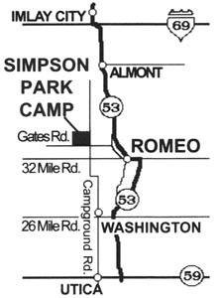
Simpson Park Camp-Summer Games
70199 Campground Rd.
Romeo, MI 48065
(586) 752-3202
www.simpsonparkcamp.org

Directions: Simpson Park Camp is in Romeo, MI.
The camp is located 1 mile West of Van Dyke Rd (M53) and ½ mile North of 32 mile Rd, on
the West side of Campground Rd.

What to Bring to Camp: (a basic list)

__ Health History-completed and signed __Swim wear (no 2 piece for girls)
__Signed Agreement to Participate __Flip flops
__Warm bedding or sleeping bag/pillow __Flashlight, personal articles
__Soap, towel, toothbrush, toothpaste __Bible, pencil/pen, writing tablet
__Jacket, long pants, long-sleeved shirt __Medications (in original, labeled containers)
__Sport or casual clothes & 2 pairs of shoes __Paper, envelopes, stamps (optional)
(No open toes or sandals) __Confirmation letter
__Fitted twin sheet to cover mattress __Dirty clothes bag (i.e. garbage bag)

